**PORTLAND PROJECT**

**PORTLAND CENTER PLAZA**

**THE LINC**



**SATURDAY, MAY 9th , 2020**

6:30 AM Arrived on site and went over briefings with Officer King and Paul

7:00 AM Conducted a walking patrol of the PCP storefront area, There was one individual skateboarding on property. I asked him to stop the skateboarding on property. Then continued my patrol.

7:30 AM Demonstrated a walking patrol of the Linc Apartments perimeter and garbage areas. No problems detected. Temperature began increasing significantly.

8:00 AM Stationed vehicle in PCP parking lot for storefront surveillance. Foot traffic had a slight increase at this time.

8:45 AM On a foot patrol headed to Linc, I came upon a middle aged woman, short hair, wearing pink, who had the contents of her bag spread out across the concrete. It appeared she was going to litter on the property so I approached her and explained the situation. Her companion shortly approached and sat with her as well. I detailed to them that this was private property and that they weren't allowed to spread their things out and loiter for an extended period of time. They eventually moved on, and I picked up some of the trash they left behind.

9:30 AM Conducted another walking patrol to the area the previous interaction had been at. No issues detected. Further patrolled Linc parking and pool areas. No issues present at this time.

10:00 AM Performed a vehicle patrol of the surrounding Linc and PCP areas. Checked garbage and parking areas for discrepancies. None were detected.

10:30 AM Conducted another vehicle patrol of the PCP parking area and surrounding perimeter. There continued to be no signs of illegal activity.

11:15 AM Conducted a foot patrol from Linc apartment parking area to PCP storefronts. Individual spotted in PCP with no shirt on, appeared transient looking, but was not loitering for a significant amount of time. Nothing else to report.

12:30 PM Began a walking patrol of the backside of all PCP storefronts, including garbage areas and walkway to park. No issues present at this time.

1:00 PM Stationed my person outside Plaid Pantry walking area to deter potential crime and keep surveillance on the site.

1:15 PM Continued patrolling to Linc pool and gym areas. Also checked the West side walkway for potential issues. No problems detected.

2:30 PM Initiated a driving patrol of the Linc parking and garbage area, then proceeded to station vehicle outside in the PCP parking area. Nothing else to report.

3:15 PM Continued surveillance of the PCP parking area. Nothing out of the ordinary.

4:00 PM Received call from Ashley who said she has been getting calls about a man, wearing glasses and with paint of some kind on him, knocking on windows and asking for money in the parking lot. I immediately responded and found no signs of the individual in or around the parking lot. I further patrolled the inside of P1 and P2 lots to ensure there would be no prowling on our vehicles by this individual. After multiple patrols, there was still no sign of the individual.

4:20 PM About this time, I received another phone call from Ashley reporting that the man had found his way into the 301 building and was knocking on doors on the 14th (Pent House) floor still asking for money. I responded to 301 and went to the 14th floor. There was no sign of the individual, but proceeded to the floor below in case he was going down the floors. When patrolling the hallways, and returning to the elevator, I saw a man slightly matching the description since he had glasses, but otherwise appeared normal. I didn't take action based on the chance that it could have been a tenant that happened to wear glasses. At this point I called Ashley back for another run down on the description of the man. She mentioned his hair was in a knot. That led me to believe this was indeed the suspect. I quickly followed him to the first floor and walked off property with him. When we were off property, I politely informed him he was not allowed back on property and would be considered trespassing next time he was spotted. He claimed he was "here every day" and that is was "weird" that I would tell him that. I reiterated that I knew he wasn't from here and he wasn't allowed back. He walked towards the park on the North side. I reported the details to Ashley and left the scene.

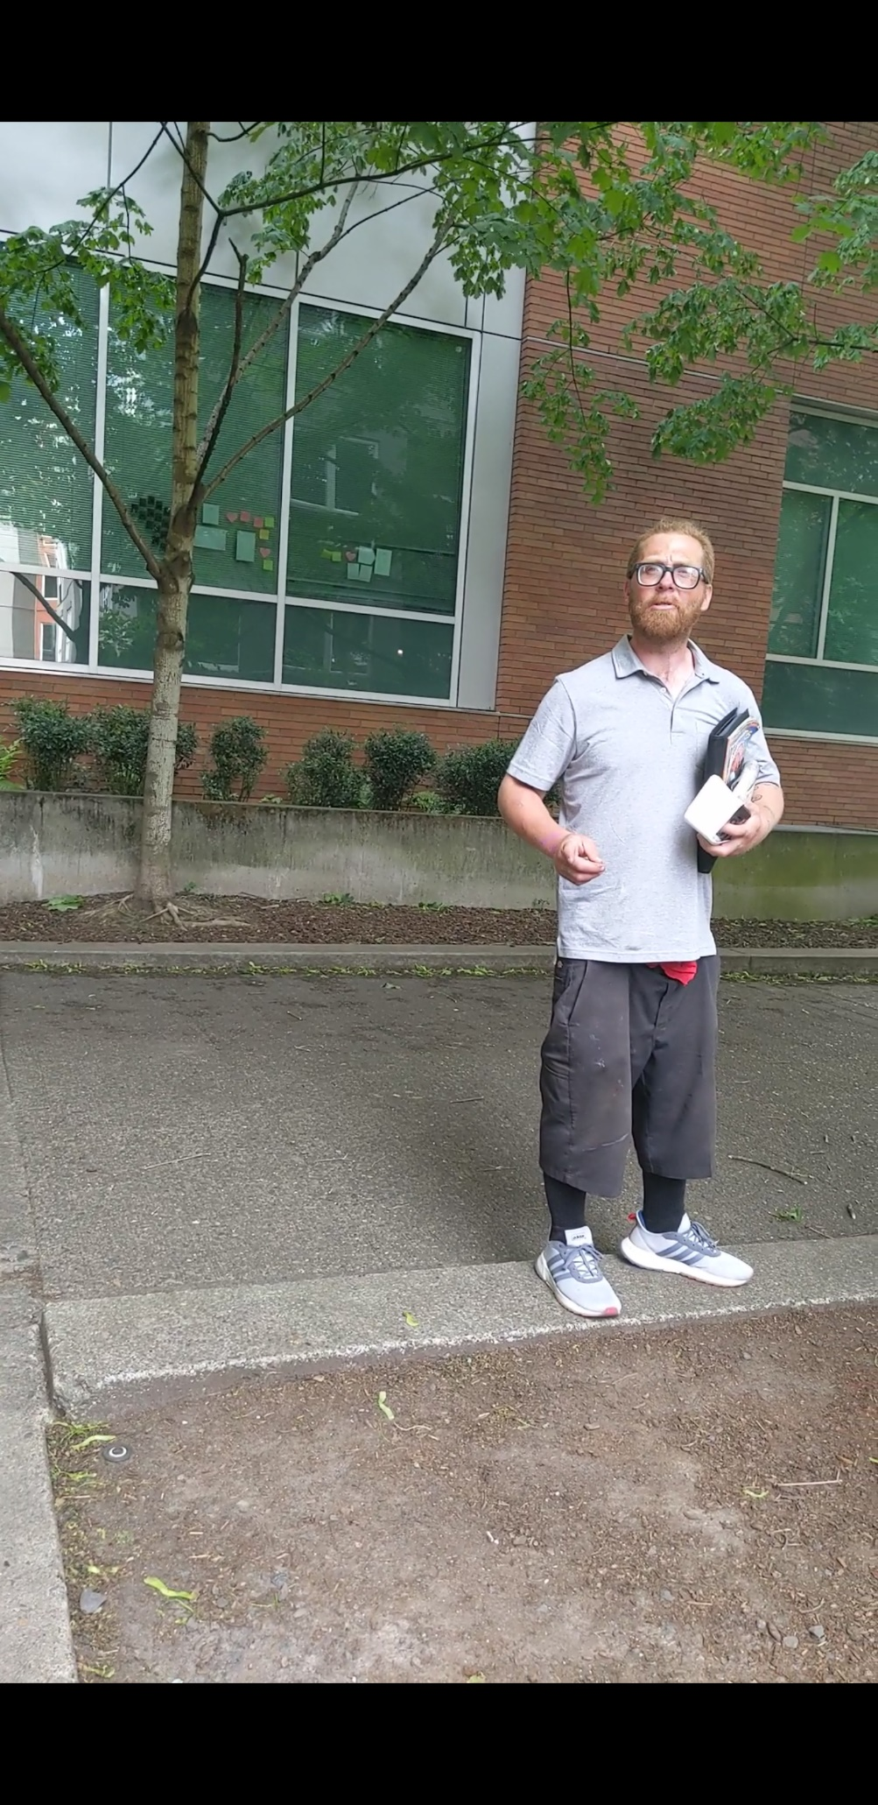

5:00 PM Began a foot patrol of Linc parking lot area and the perimeter. Including garbage and pool area. No problems at this time.

5:30 PM Stationed myself outside the Plaid Pantry for parking lot surveillance. No issues present at this time.

6:00 PM Began patrol of all surrounding PCP areas including waste disposal, storefronts, and perimeter walkways. No problems at this time.

**\*\*\*\*\*\*\*\*\*\*\*\*\*\*\*\*\*\*\*\*\*\*\*\*\*\*\*\*\*END OF REPORT\*\*\*\*\*\*\*\*\*\*\*\*\*\*\*\*\*\*\*\*\*\*\*\*\*\*\*\*\*\*\***